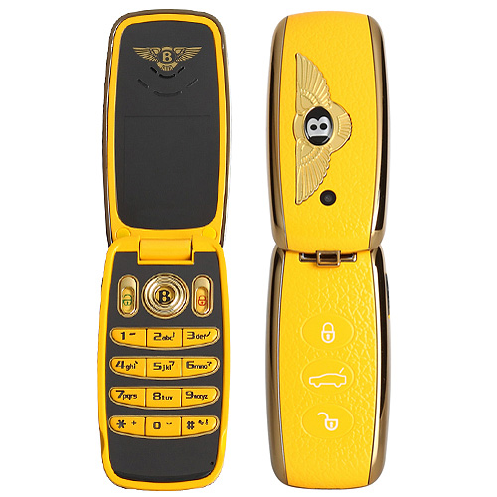

1 and 2

One SIM One Standby

Bands: GSM900/1800MHz

Languages: English and other languages

LCD: 1.4 inch QCF color screen

TV: No

FM radio: No

MP3: Yes

MP4: Yes,

Bluetooth: Yes

Memory: Support T-flash slot

Camera: 1.3Mega

Battery: 500mAh.

Standby time: 60hours

Standard Accessories:

two batterys, one charger, one earphone, one date cable, one keychain

Colors: Black, White, Red,Blue, Orange

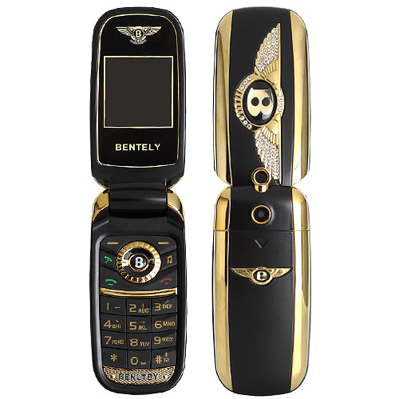

5

Frequency GSM900/1800MHz/850/1900MHz

Platform MTK52D

Color black,red,gray,sliver

Type Dual SIM Dual Standby

Bluetooth Yes

FM Yes

Camera 0.3MP

Display 1.44inch

Memory support T-flash card

Weight About 95g

Battery 380mah

Standby time About 5days

Main function MP3/MP4, FM, Bluetooth, Camera, LED Flashlight, T-flash Card

Additional calculator,to-do list,world time,alarm etc.

Accessories 1\*battery,1\*charger,1\*manual book,1\*USB cable,1\*earphone

Language:Multi

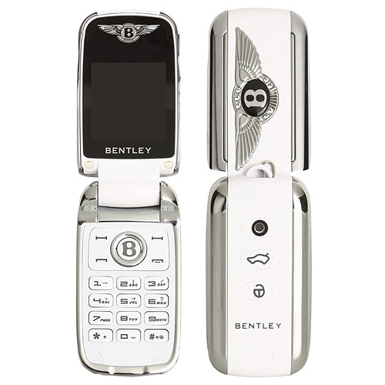

3 and 4

frequency:Dual band 900/1800MHz

network GSM

screen:1.2 inch OLED color screen( 240×320 )

Platform:MTK MT6252A

Audio:mp3/4,FM

Memory:64M+0

T-Flash Card:support, Max 4G

Color:black/white/red/Blue

Language:Chinese, English, French, German, Turkish, more text, Bahasa Indonesia,

Russian, Thai, Portuguese, Spanish, Persian, Arabic

Bluetooth:Support

camera:Yes

SMS/MMS:support SMS

SIM cards:Dual sim card

otherfunciton:Bluetooth,MP3,hand-free, T-Flash card, Calender,calculator, Alarm

Accessories:earphone\*1,battery\*2,USB cable\*1,key chain\*1,charger\*1